**Adjustments to be made to SORT coding:**

**Making it a two-response (left/right arrow) instead of Go/NoGo task.**

At the moment, I am just hoping to modify the script/task to pilot behaviourally outside the scanner. But later down the track, it will need to be modified again to be MRI compatible (which I think is a lot of coded out aspects in the current script).

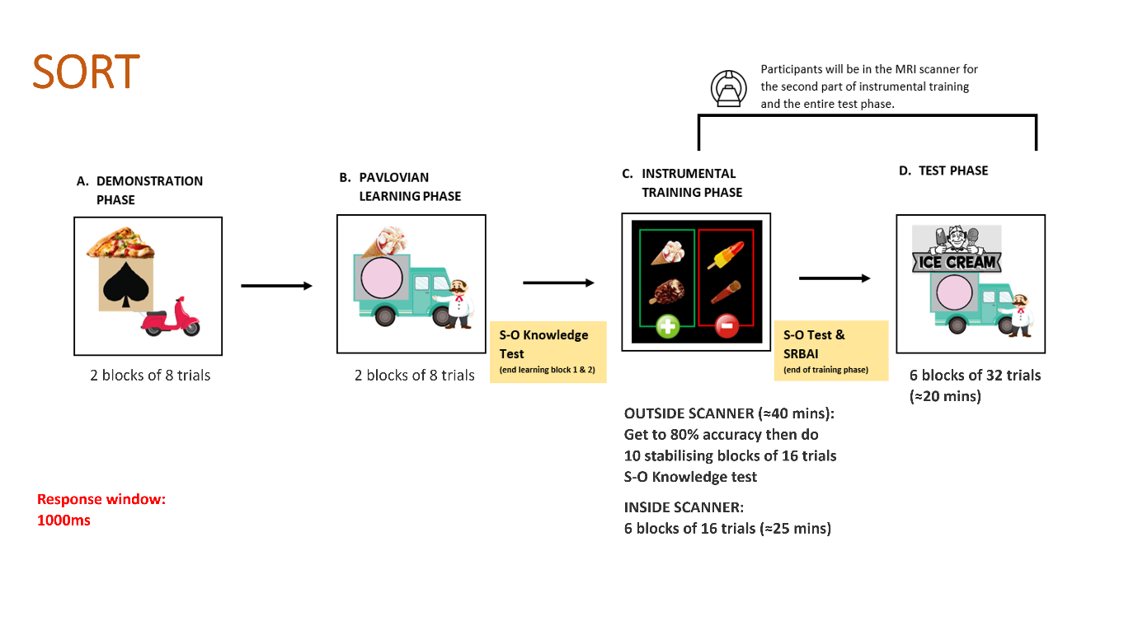

**Adjust instruction slides & text** – DONE.

**Increase response window to 1000ms** – DONE.   
*Although I noticed that this version of the task has two response window lengths (short & long - int mov_dur_test1 & int mov_dur_test2). I just changed both to 1000ms as I wasn’t sure how to get rid of the second window.

**Adjust number of trials/blocks**  
We were thinking of having participants continue to complete the training blocks until they reach 80% accuracy and then do 10 stabilising blocks of 16 trials outside the scanner.

**Adjust responses so that Go trials (spacebar) are now left arrow key and NoGo responses now right arrow key (e.g., left arrow key = valuable, right arrow key = nonvaluable).**\* We are also in the process of sourcing a four button box for outside of the scanner trials. Once it arrives will need to change the code from left/right to be two of those buttons.